Example of Marketing Calendar w/ Workshops and Webinars:
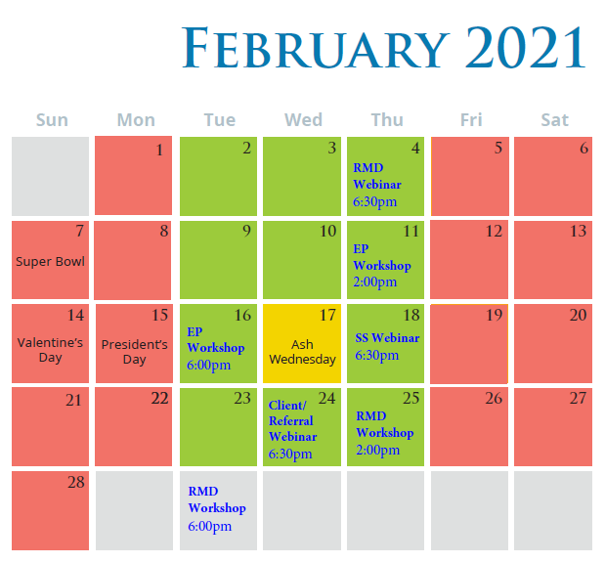
- 2 mailing campaigns for educational workshops ($5.5K per campaign = $11K)
- 2 digital campaigns for live webinars ($1.5K per campaign = $3K)
- 1 internal campaign for client/referral live webinar (Free)

Example of Marketing Calendar w/ Webinars Only:
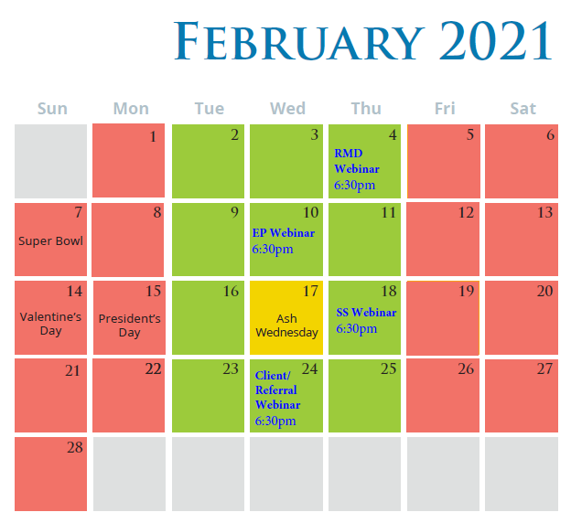
- 3 digital campaigns for live webinars ($1.5K per campaign = $4.5K)
- 1 internal campaign for client/referral live webinar (Free)

